**FPT ACADEMY INTERNATIONAL**



## FPT – APTECH COMPUTER EDUCATION

CARVAN

|  |  |  |  |
| --- | --- | --- | --- |
| **Center Name** | | FPT – Aptech – HCM2  Address: 590 Cach Mang Thang Tam, District 3, Ho Chi Minh City | |
| **Instructor** |  | Ms. Le Mong Thuy |  |
| **Class** |  | T1.2007.E1 |  |
| **Group** |  | 5 |  |
| **Group members** | | **Name** | **Student ID** |
|  |  | Kiều Trịnh Khôi | Student1270677 |
|  |  | Âu Phúc Thiện | Student1271296 |
|  |  | Nguyễn Thái Hòa | Student1254039 |
| **Duration** | Start date | 19th September 2020 |  |
| End date | 17th October 2020 |  |

**This is to certify that**

**Mr.:**

Kiều Trịnh Khôi

Âu Phúc Thiện

Nguyễn Thái Hòa

**has successfully designed & developed**

eProject: CARVAN website

**Submitted by:**

Kieu Trinh Khoi

**Date of issue:**

**Authorized Signature:**



**TABLE OF CONTENTS**

FPT – APTECH COMPUTER EDUCATION 1

ACKNOWLEGMENT 3

SYNOSIS 3

PROBLEM DEFINITION 3

CUSTOMER'S REQUIREMENTS SPECIFICATIONS (CRS) 4

Business/Project Objective: 4

Hardware/ Software Requirements: 5

SCOPE OF THE WORK (IN BRIEF) 6

Architecture and design of the system 7

Diagram of the website 8

TASK SHEET REVIEW 1 9

SITE MAP 10

MOCK OF THE WEBSITE 11

**1.** **Homepage** 11

**2.** **Brands (Kia – Ford – Toyota)** 12

**3.** **PreOwned Car** 13

**4.** **About us** 14

**5.** **Contact us** 15

TASK SHEET REVIEW 2 16

WEBSITE DESCRIPTION 17

**1.** **Home Page** 17

**2.** **Brands** 21

**3.** **Range of car** 24

**4.** **Preowned Car** 24

**5.** **Contact us** 26

**6.** **About us** 27

**1.** **Menu 2nd in product site javascript** 29

a) Decrription 29

This script used fixed menu 2nd on top and hide menu 1st the website. 29

b) Screen shot 29

29

**2.** **Button ScrollTop Javascript** 30

a) Description 30

This script is used for controlling button show when scroll down the page, and will hide if the page return top. 30

b) Screen shot 30

**3.** **Menu sort Javascript** 31

a) Description 31

This script is used in conjunction with isotope.js 31

b) Screen shot 31

31

TASK SHEET REVIEW 3 32

# ACKNOWLEGMENT

On behalf of all the members of group 2, I would like to thank you all for the hard works, supports to make this eProject complete successfully. Especially, Ms. Le Mong Thuy, our teacher, she helped us a lot from the day that we started to study at FPT Aptech. With this eProject, she has guided us with her enthusiasm and rigorous, because of her guiding, we would be able to finish this project. Besides, I want to thank all the team member of group 2, each of the team member has been working continuously in 4 weeks in order to complete this project. The last but not least, we would like to say thank you to our family for always supporting us, creating the best conditions for us to focus on the project, and putting faith in the dreams we pursue.

# SYNOSIS

We need to create a website that meet all the requirement of our customer, CARVAN. They have a big collection about models and brands of car as well. The main purpose of this website is to reach to the customer, who have interest in vehicle and looking for a car that they can use with their passion.

# PROBLEM DEFINITION

The Web site is to be created based on the following requirements.

1. The Home Page should be created making use of Frames with a suitable logo
2. The site should display a menu with following categories:

* About Us
* Brands
* Range of Cars
* PreOwned Cars
* Contact Us

1. ‘Brands’ should contains details about various brands/companies and sub-menu with Car Models for each brand/company should be provided.
2. ‘Range of Cars’ menu option should provide details in terms of ‘Small Car’, ‘SEDAN’, ‘VAN’, ‘JEEPS’ etc.
3. ‘PreOwned’ menu option should provide details about the characters in the parks and a small story should be associated to them.
4. ‘About Us’ should provide details of the company and past and upcoming events.
5. There should be a “Contact Us” page which will have the Address of the Company which is as follows and the mail address which when clicked will invoke the local mail client from where they can send an email. Address of the Company should be displayed using GeoLocation API (eg. GoogleMaps).

# CUSTOMER'S REQUIREMENTS SPECIFICATIONS (CRS)

**Client: VANCAR**

### Business/Project Objective:

The ‘CARVAN’ is largest online car market. It caters to needs of everyone, be it a family, business or individuals. This initiative is aimed towards providing information and details about CAR’s to buyers.

The site provides details and specifications of various models offered by the companies. It also provide pictures and images to have a better look.

‘CARVAN’ is looking to restructure the entire website to provide information and also connect with prospective customers.

The website is to be developed for the Windows Platform using HTML5, JavaScript and Geolocation. The site should work well in all leading browsers including Chrome, IE, Firefox etc.

**Input to the system:**

* + - * Searching products based on brands, range of car.
      * Information about Preowned cars.

**Output from the system:**

* A menu that will categorize all the functions of the site.
* Perform the search based on a particular: brands, range of cars.
* Display the details about the characters in the Preowned Cars and a small story should be associated to them.
* Site should be able to provide brief introduction/history about the showroom under About Us page.
* The location of the showroom under Contact-Us page.
* Besides the above requirements, the site should have look and feel as per the industry standards.

**Process**:

* + - * Validate data input from users.

**Expected delivery date:** 17-October-2020.

**List of deliverables:**

* + - * Document Word.
      * User Guide.
      * Source code.

### Hardware/ Software Requirements:

* **For developer**

**Hardware**

* + Intel Pentium 4 processor or higher
  + 1 Gigabytes of RAM or higher

**Software**

* + Windows 7 OS or higher
  + Adobe Dreamweaver
  + Web browsers such as IE, Chrome or Firefox are supporting HTML5, CSS3 and Javascript.
* **For web users**

**Hardware**

* + Intel Pentium 4 processor or higher
  + 512 Megabytes of RAM or higher

**Software**

* + Windows XP OS or higher
  + Web browsers such as IE, Chrome or Firefox are supporting HTML5, CSS3 and Javascript.

# SCOPE OF THE WORK (IN BRIEF)

After a long and detailed discussion, our group has decided to create a website contain the following webpages:

1. ***Homepage***: Display information about newest-selling products, an introduction about CARVAN.
2. ***Brands***: Display all models of brands based on category (AUDI, BMW, MERCEDES).
3. ***Range of cars***: Give information about ‘SEDAN’, ‘CROSSOVER’, ‘SUV’ etc.
4. ***Preowned cars***: Display the details about the characters in the park and a small story should be associated to them.
5. ***About Us***: Display the information of the company, clients’ review and about us.
6. ***Contact***: Display the address of the company, allow customers to request any information they want to CARVAN.

# Architecture and design of the system

Webpage request



Requested Page

**RENDERING**

**ENGINE**

**CSS CODE**

**HTML CODE**

**WEB SERVER**

**WEB BROWSER**

**CLIENT**

**SERVER**

# Diagram of the website

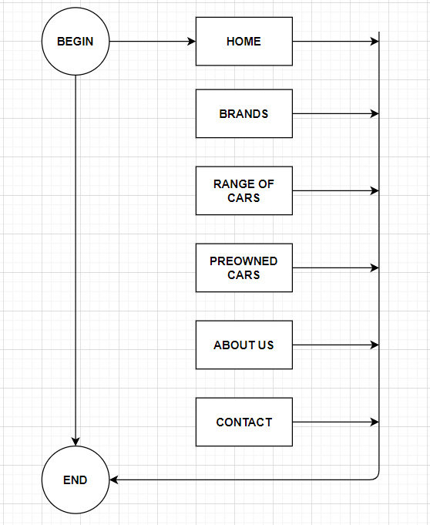



# TASK SHEET REVIEW 1

|  |  |  |  |  |  |  |  |
| --- | --- | --- | --- | --- | --- | --- | --- |
| **Project Ref. No.:**  **eP/Advertisement Portal Management**  **System/01** | | **Project Title:** | **Activity Plan Prepared By:** | **Date of Preparation of Activity Plan:** | | | |
| **Sr.**  **No.** | **Task** | **Actual**  **Start Date** | **Actual Days** | **Team**  **Mate Names** | **Status** |
| 1 | Problem Statement | CARVAN | Khoi | 19-Sep-20 | 1 | Thien | Completed |
| 2 | Analysis of CARVAN requirements about the website | 19-Sep-20 | 1 | Thien | Completed |
| 3 | The scope of the work (in brief) | 19-Sep-20 | 1 | Khoi | Completed |
| 4 | Architecture and design of the system | 19-Sep-20 | 1 | Khoi | Completed |
| 5 | Diagram of the website | 19-Sep-20 | 1 | Hoa | Completed |
| 6 | Task Sheet | 19-Sep-20 | 1 | Hoa | Completed |

|  |  |
| --- | --- |
| **Date:** | |
| Signature of Instructor:  **Ms. Le Mong Thuy** | Signature of Team Leader:    **Kieu Trinh Khoi** |

# SITE MAP

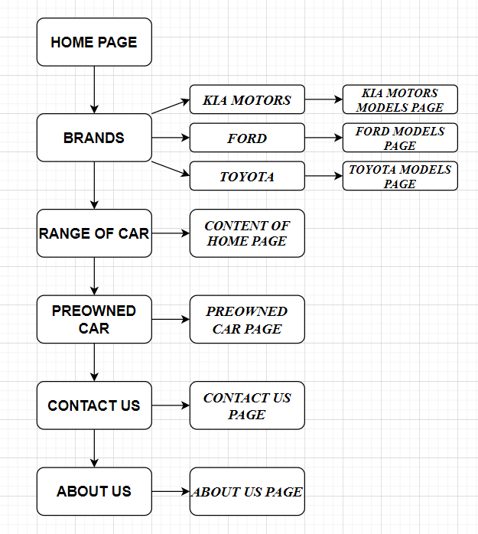

# MOCK OF THE WEBSITE

1. **Homepage**

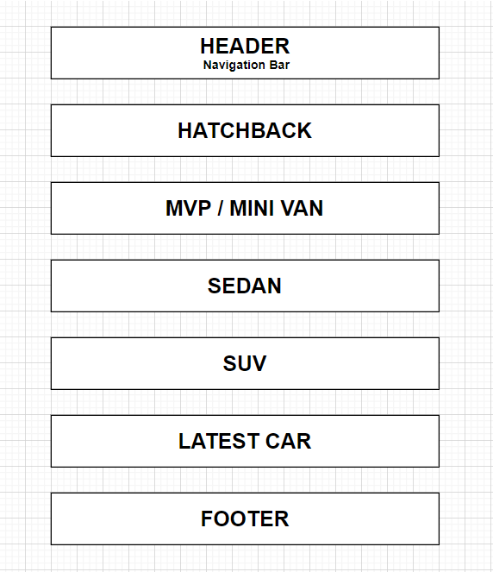

1. **Brands (Kia – Ford – Toyota)**

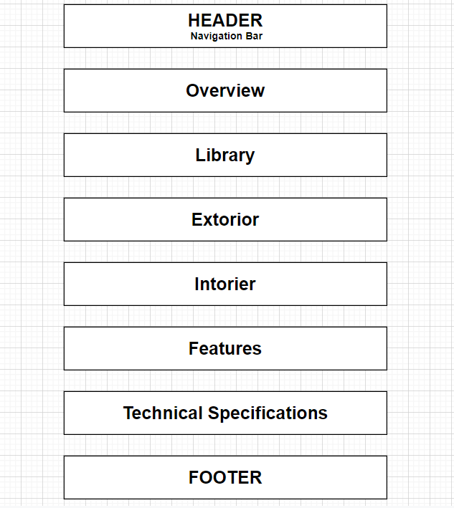

1. **PreOwned Car**

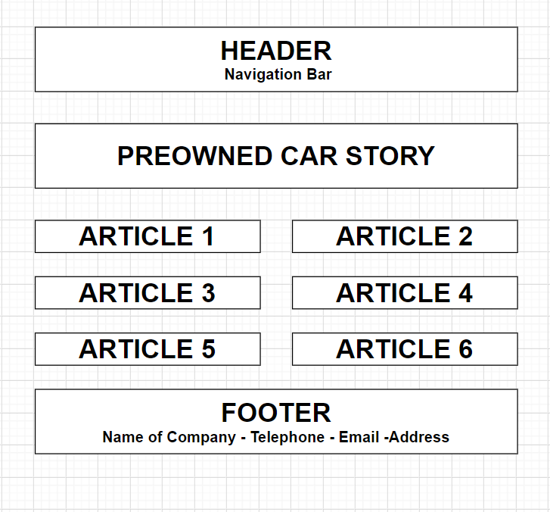

1. **About us**

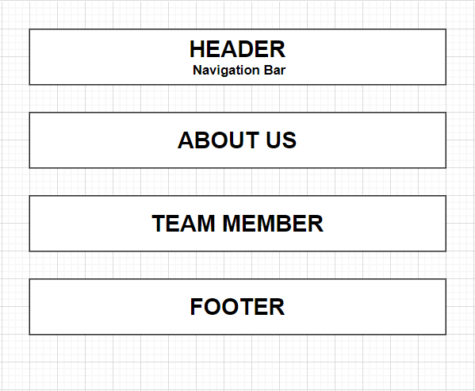

1. **Contact us**

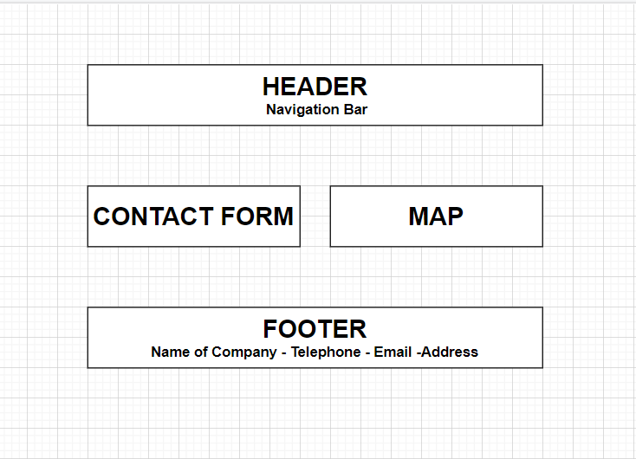

# TASK SHEET REVIEW 2

|  |  |  |  |  |  |  |  |
| --- | --- | --- | --- | --- | --- | --- | --- |
| **Project Ref. No.:**  **eP/Advertisement**  **Portal Management System/01** | | **Project Title:** | **Activity Plan Prepared By:** | **Date of Preparation of Activity Plan:** | | | |
| **Sr.**  **No.** | **Task** | **Actual Start Date** | **Actual Days** | **Team Mate Names** | **Status** |
| 1 | Site map | CARVAN | Khoi | 26-Sep-20 | 1 | Thien | Completed |
| 2 | Mock of the website | 26-Sep-20 | 2 | Khoi | Completed |
| 3 | Task sheet | 26-Sep-20 | 2 | Hoa | Completed |

|  |  |
| --- | --- |
| **Date:** | |
| Signature of Instructor:  **Ms. Le Mong Thuy** | Signature of Team Leader:  **Kieu Trinh Khoi** |

# WEBSITE DESCRIPTION

1. **Home Page**
2. Description

Home page displays following information:

* Introduce about brands of car.
* Range of car (HATCHBACK – MPV / VAN – SEDAN – SUV / CROSSOVER)
* Latest cars.

1. 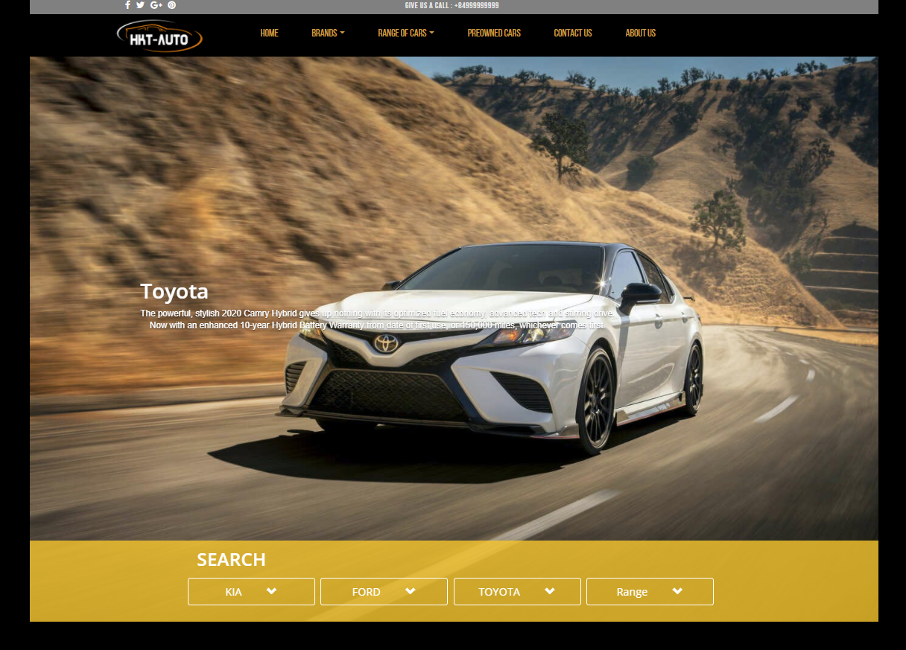Screen shot

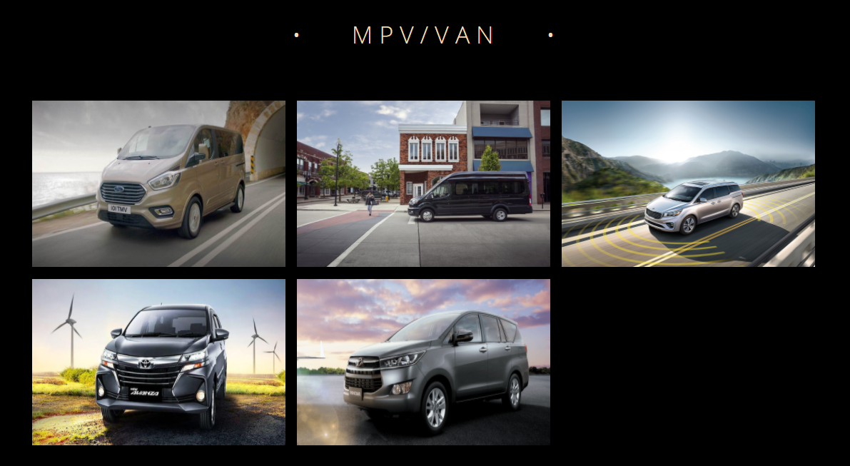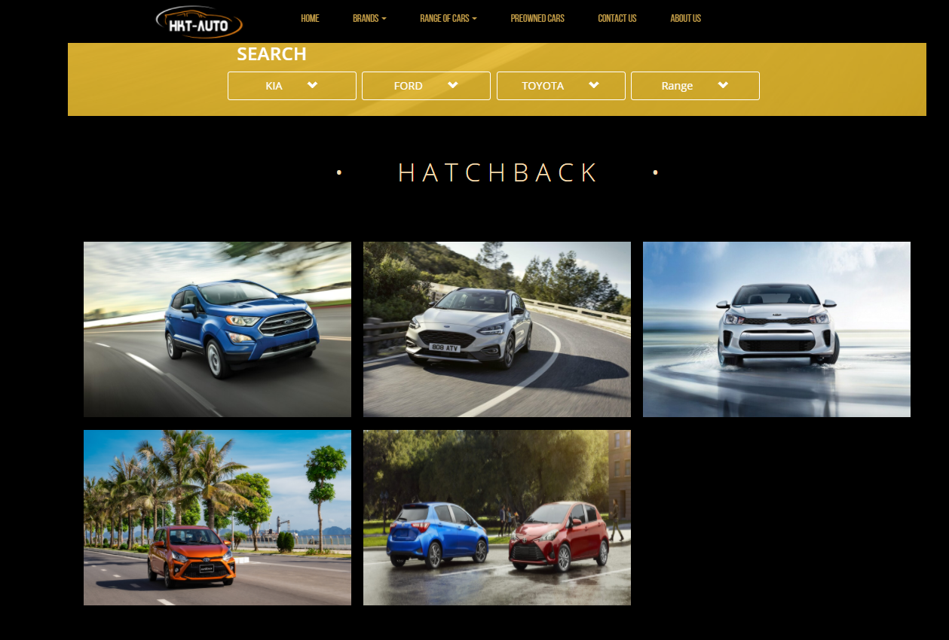

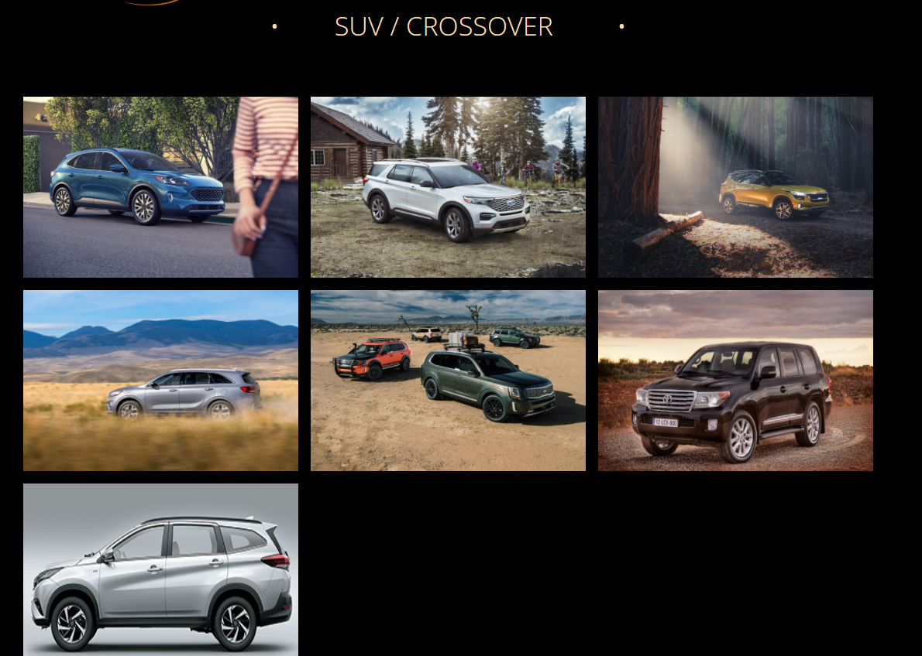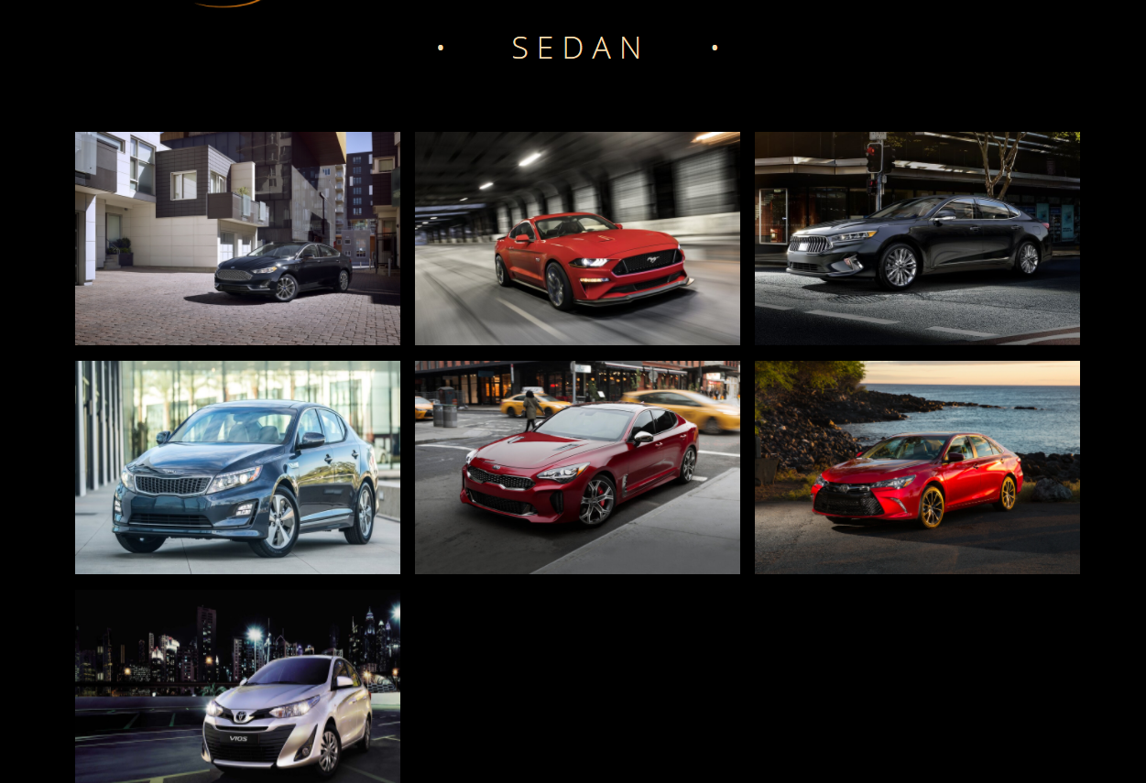

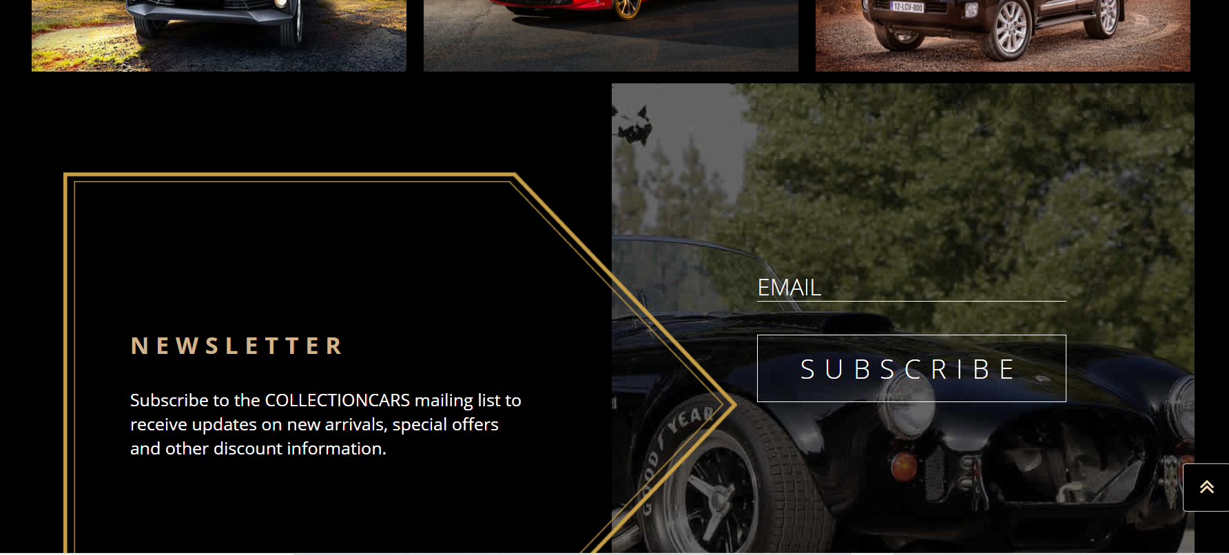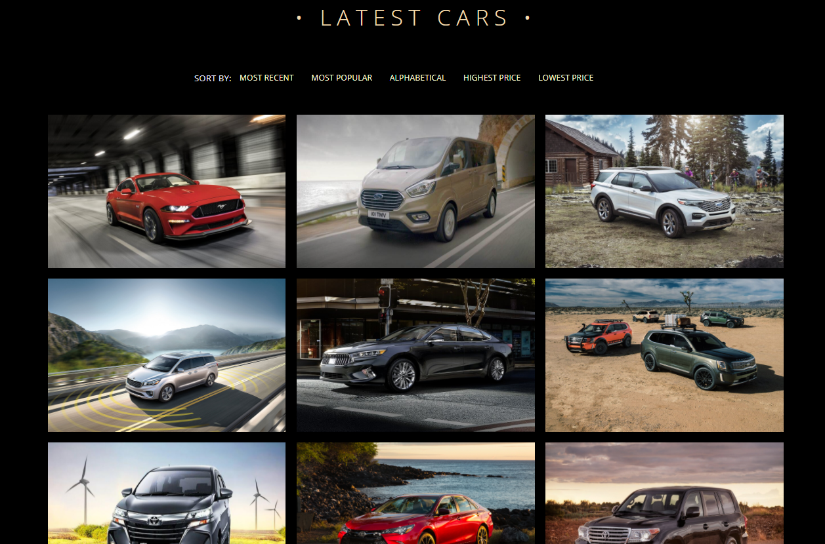

1. **Brands**
2. Description

This shop page displays following information:

All product that being sold CARVAN when click on 1 specific item, it will show the detail of that item.

1. 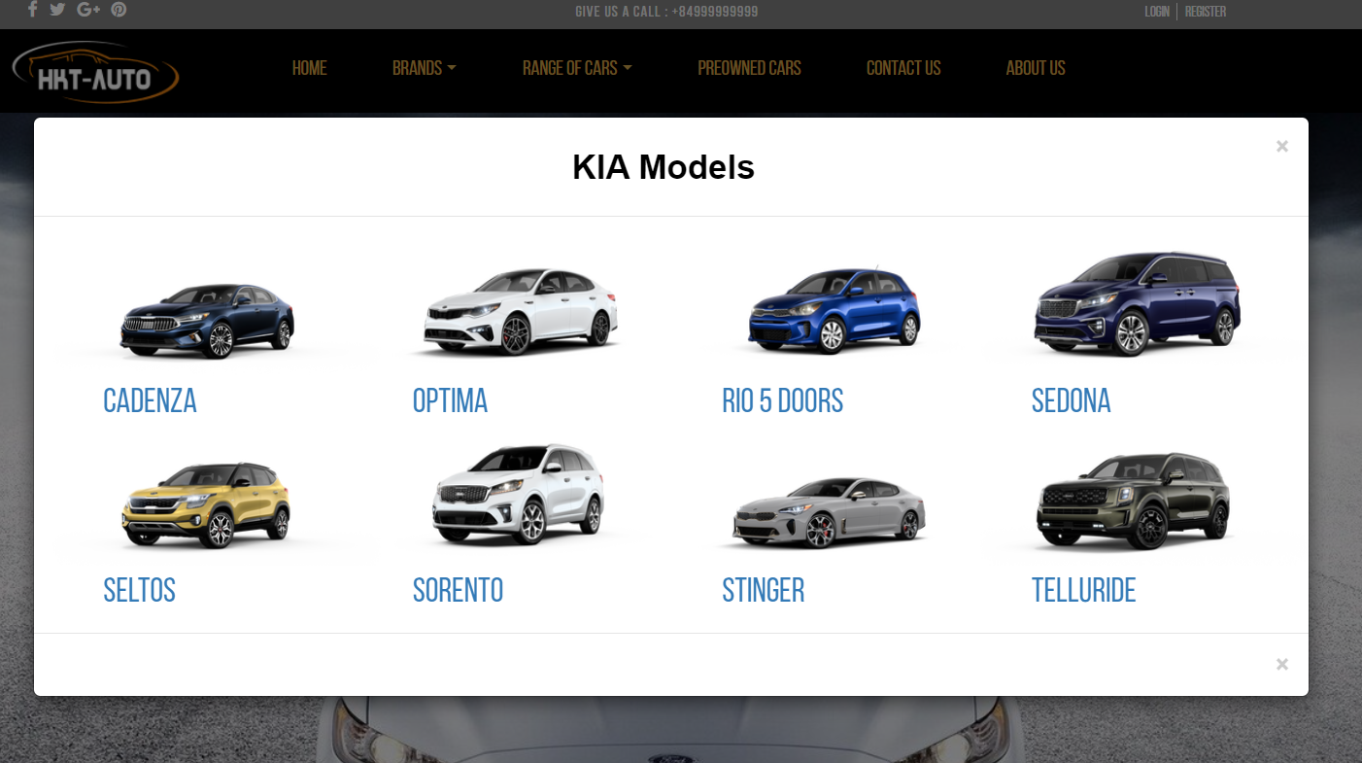Screen shot

Detail product:

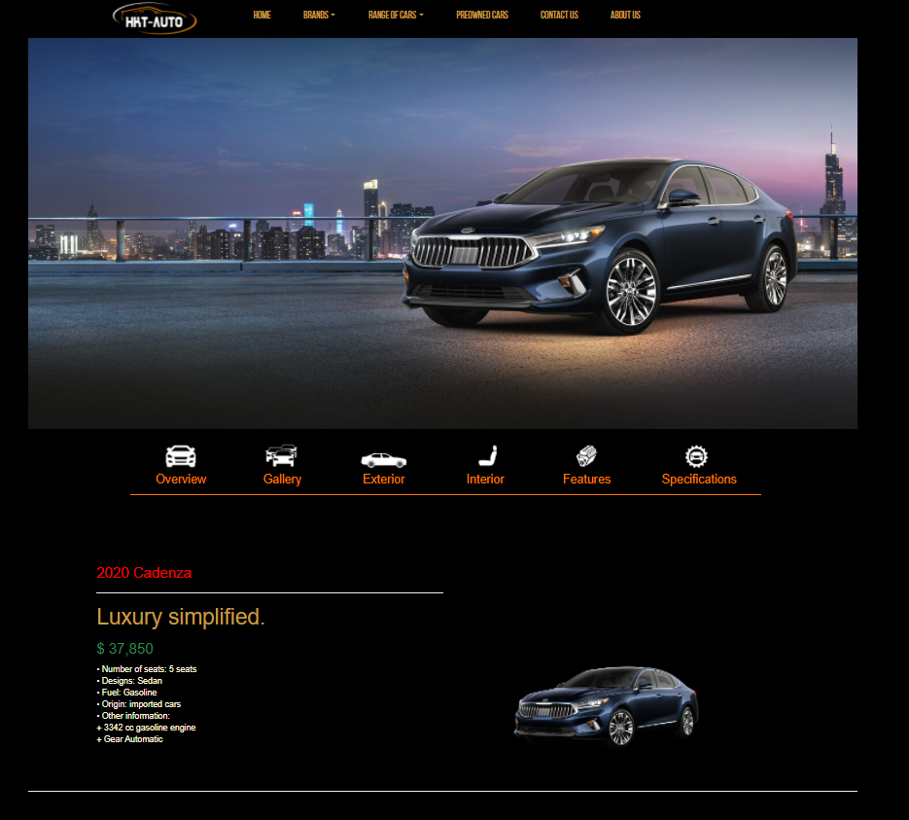

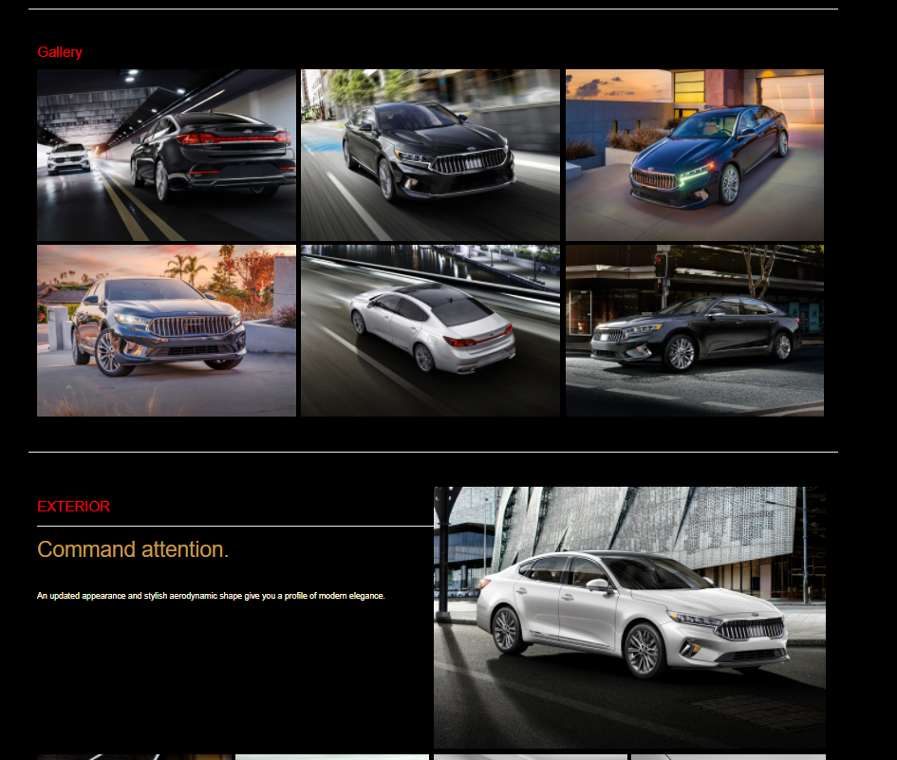

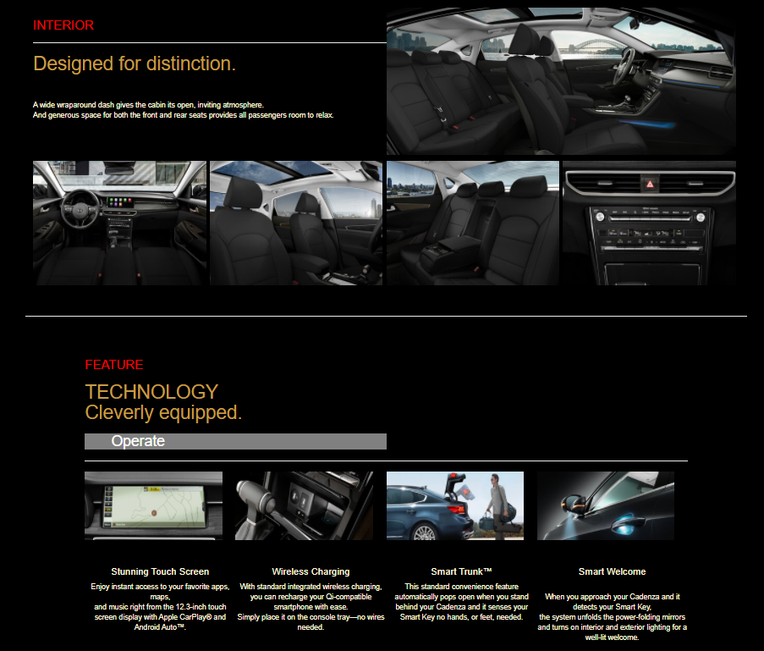

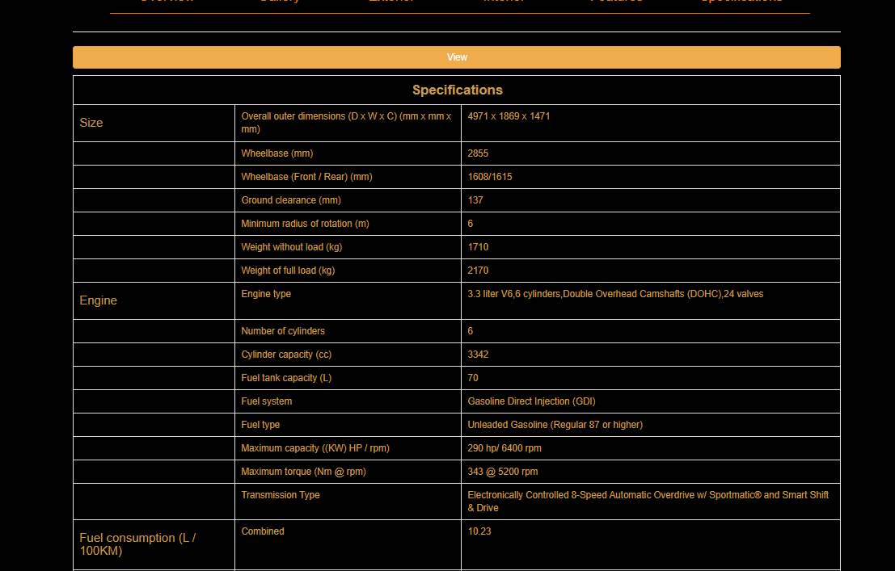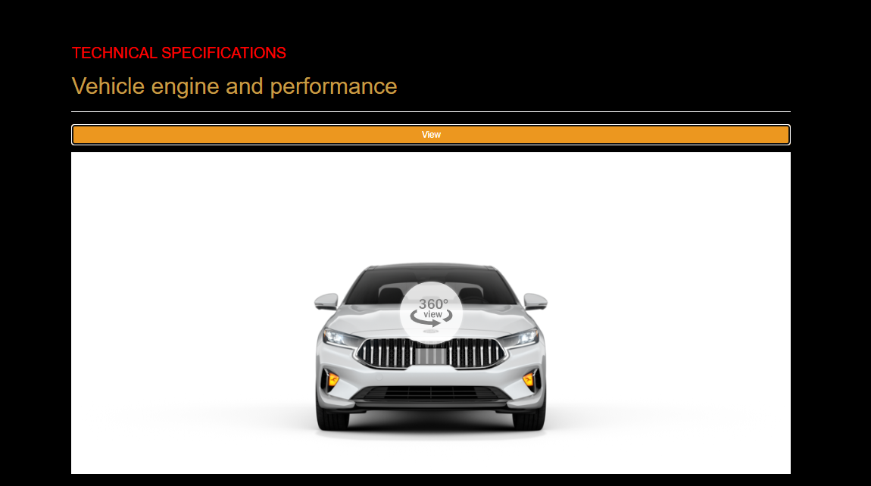

1. **Range of car**

Description:

* This part is shown on homepage.

1. **Preowned Car**
2. Description

This page displays some articles about CPO (Certified Pre-Owned car),

when click on 1 specific item, it will show the detail of that item.

1. Screen shot

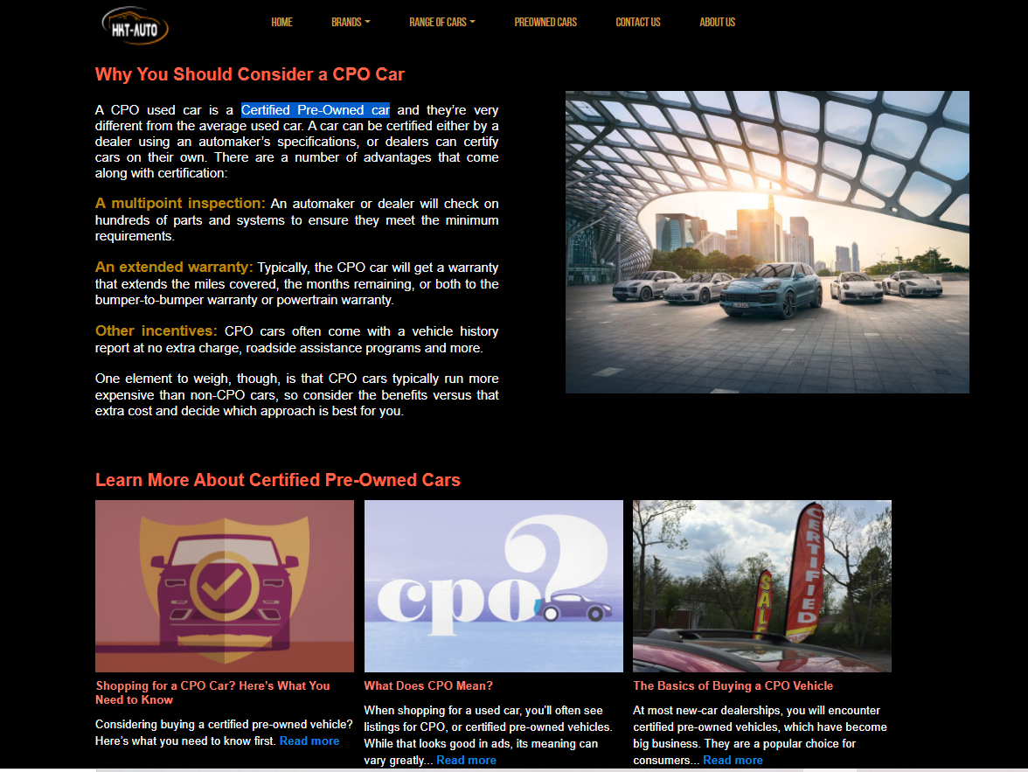

Detail article:

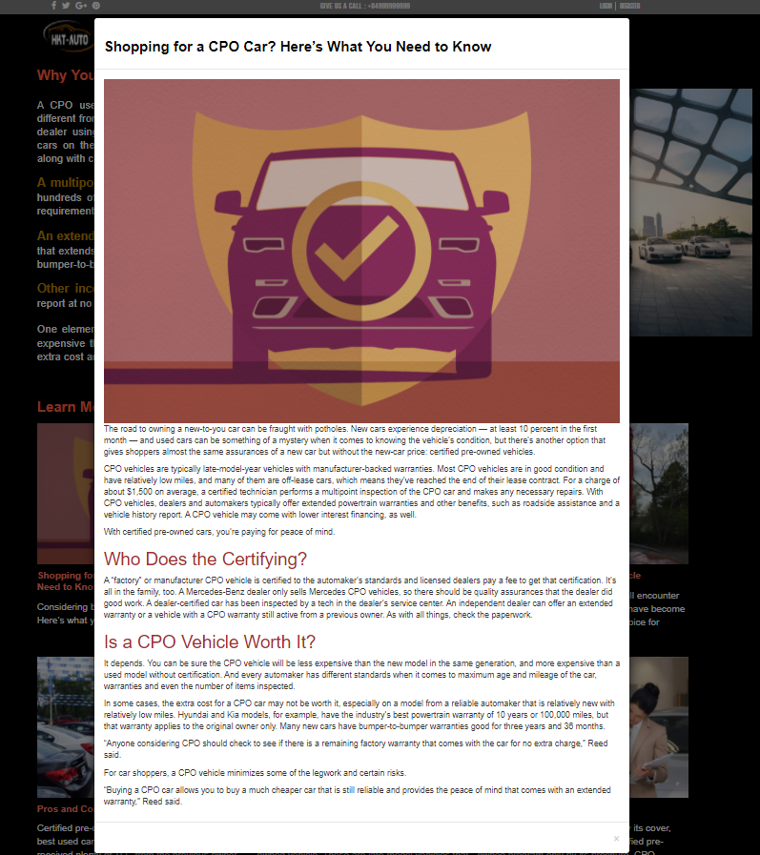

1. **Contact us**
2. Description

This page displays contact information: location, telephone number, email and a quick contact form for customer.

1. Screen shot

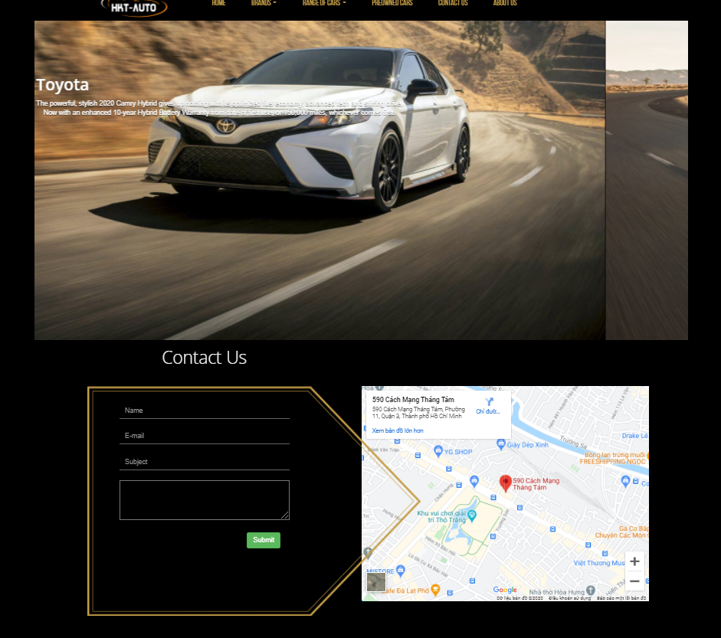

1. **About us**
2. Description

This page displays information about the history of CARVAN, our service that we provide and our team member.

1. Screen shot

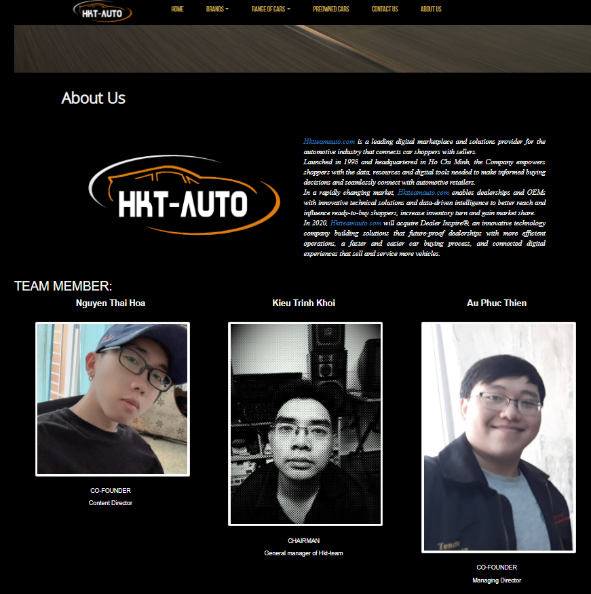

**RESPONSIVE**

The page has responsive feature for small screen device such as smart phone, tablet, etc

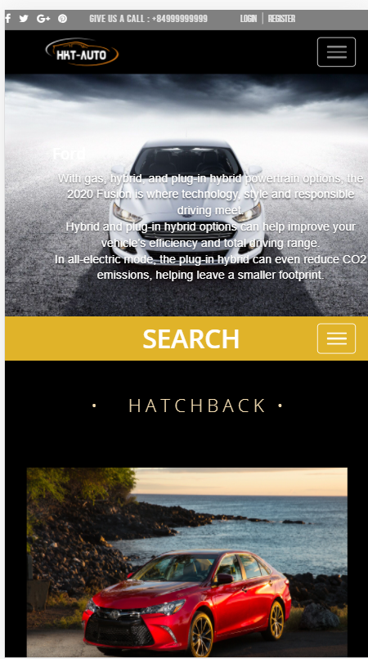

**JAVASCRIPT DESCRIPTION**

1. **Menu 2nd in product site javascript**
2. Decrription

This script used fixed menu 2nd on top and hide menu 1st the website.

1. Screen shot

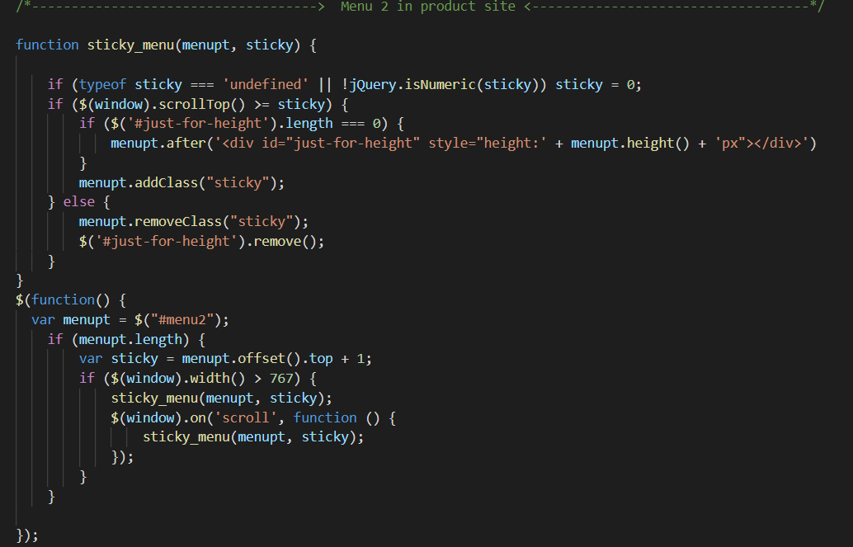

1. **Button ScrollTop Javascript**
2. Description

This script is used for controlling button show when scroll down the page, and will hide if the page return top.

1. 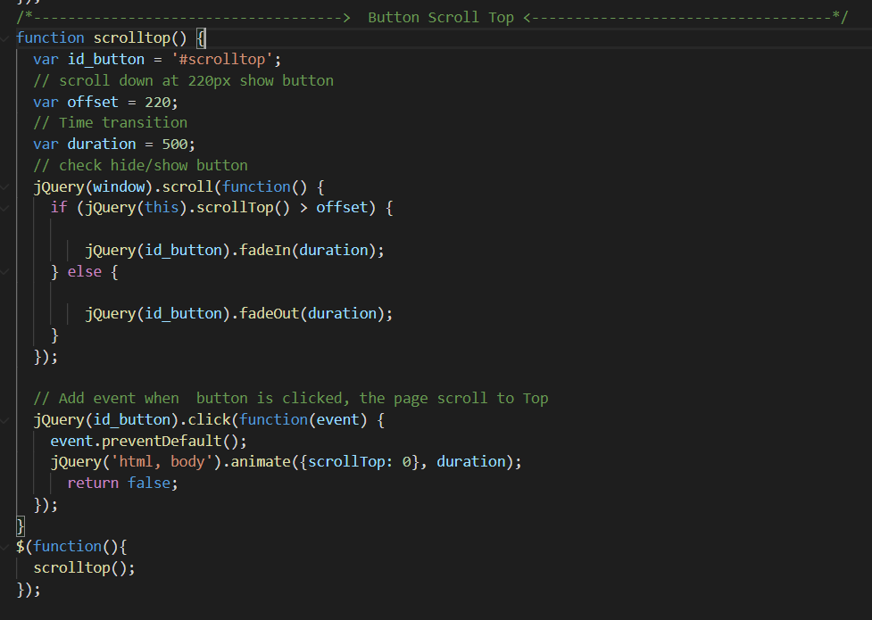Screen shot
2. **Menu sort Javascript**
3. Description

This script is used in conjunction with isotope.js

1. Screen shot

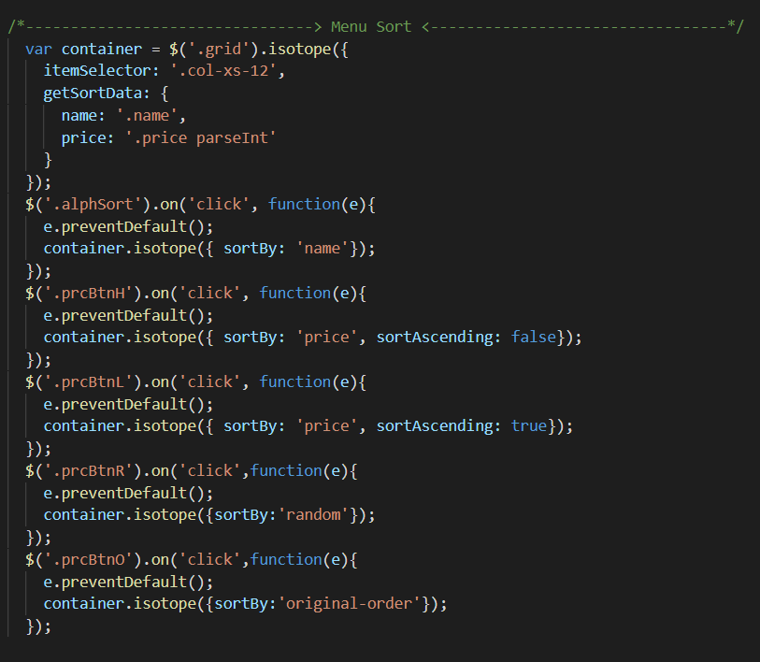

# TASK SHEET REVIEW 3

|  |  |  |  |  |  |  |  |
| --- | --- | --- | --- | --- | --- | --- | --- |
| ***Project Ref. No.:***  ***eP/Advertisement Portal Management System/01*** | | ***Project Title:*** | ***Activity Plan Prepared By:*** | ***Date of Preparation of Activity Plan:*** | | | |
| ***Sr.***  ***No.*** | ***Task*** | ***Actual Start***  ***Date*** | ***Actual Days*** | ***Team Mate***  ***Names*** | ***Status*** |
| *1* | *Home page* | *CARVAN* | *Khoi* | 29-Sep-20 | *1* | *Khoi* | *Completed* |
| *2* | *Brands(KIA Models)* | 03-Oct-20 | *3* | *Thien* | *Completed* |
| *3* | *Brands(Ford Models)* | 03-Oct-20 | *3* | *Khoi* | *Completed* |
| *4* | *Brands(Toyota Models)* | 03-Oct-20 | *3* | *Hoa* | *Completed* |
| *5* | *Range of Cars* | 06-Oct-20 | *1* | *hoa* | *Completed* |
| *6* | *PreOwned Cars* | 06-Oct-20 | *1* | *Khoi* | *Completed* |
| *7* | *Contact us* | 06-Oct-20 | *1* | *Thien* | *Completed* |
| *8* | *About us* | 06-Oct-20 | *1* | *Thien* | *Completed* |
| *9* | *Responsive* | 08-Oct-20 | *1* | *Khoi* | *Completed* |
| *10* | *Javascript* | 08-Oct-20 | *1* | *Hoa* | *Pending* |
| *11* | *User Guide* | 08-Oct-20 | *1* | *Khoi* | *Pending* |
|  |  |  |  |  |  |  |  |
|  |  |  |  |  |  |  |  |
|  |  |  |  |  |  |  |  |
|  |  |  |  |  |  |  |  |
|  |  |  |  |  |  |  |  |

|  |  |
| --- | --- |
| **Date:** | |
| Signature of Instructor:  **Ms. Le Mong Thuy** | Signature of Team Leader:  **Kieu Trinh Khoi** |